# BSC10924 – Networking Technologies Grp A&B – Practical CA1

**Name: Lucas Madeira Maranho**

**Student ID: 76990**

***IMPORTANT: When saving this document please make sure that your Student ID is included in the filename.***

## Subnet 1

**Record your calculations here:**

|  |  |  |  |  |  |
| --- | --- | --- | --- | --- | --- |
|  | **Octet 1 Binary** | **Octet 2 Binary** | **Octet 3 Binary** | **Octet 4 Binary** | **IP Address / Subnet Mask in Decimal** |
| **Network Address** | **11000000** | **10101000** | **01100011** | **00000000** | **192.168.99.0** |
| **Subnet Mask** | **11111111** | **11111111** | **11111111** | **00000000** | **255.255.255.0** |
|  |  |  |  |  |  |
| **First Usable Address** | **11000000** | **10101000** | **01100011** | **00000001** | **192.168.99.1** |
| **Last Usable Address** | **11000000** | **10101000** | **01100011** | **11111110** | **192.168.99.23** |
|  |  |  |  |  |  |
| **Broadcast Address** | **11000000** | **10101000** | **01100011** | **11111111** | **192.168.99.24** |

## Subnet 2

**Record your calculations here:**

|  |  |  |  |  |  |
| --- | --- | --- | --- | --- | --- |
|  | **Octet 1 Binary** | **Octet 2 Binary** | **Octet 3 Binary** | **Octet 4 Binary** | **IP Address / Subnet Mask in Decimal** |
| **Network Address** | **11000000** | **10101000** | **01011010** | **00000000** | **192.168.90.0** |
| **Subnet Mask** | **11111111** | **11111111** | **11111111** | **00000000** | **255.255.255.0** |
|  |  |  |  |  |  |
| **First Usable Address** | **11000000** | **10101000** | **01011010** | **00000001** | **192.168.90.1** |
| **Last Usable Address** | **11000000** | **10101000** | **01011010** | **11111110** | **192.168.90.23** |
|  |  |  |  |  |  |
| **Broadcast Address** | **11000000** | **10101000** | **01011010** | **11111111** | **192.168.90.24** |

**Addressing Table**

|  |  |  |  |  |
| --- | --- | --- | --- | --- |
| **Device** | **Interface Name** | **IP Address** | **Subnet Mask** | **Default Gateway** |
| **Router R1** | **G0/0** | **192.168.99.24** | **255.255.255.0** | **192.168.99.24** |
|  | **G0/1** | **192.168.90.24** | **255.255.255.0** | **192.168.90.24** |
| **Switch S1** | **Interface VLAN1** | **192.168.99.23** | **255.255.255.0** | **192.168.99.24** |
| **Switch S2** | **Interface VLAN1** | **192.168.99.22** | **255.255.255.0** | **192.168.99.24** |
| **Switch S3** | **Interface VLAN1** | **192.168.90.23** | **255.255.255.0** | **192.168.90.24** |
| **PC1** | **Fa0** | **192.168.99.10** | **255.255.255.0** | **192.168.99.24** |
| **PC2** | **Fa0** | **192.168.99.11** | **255.255.255.0** | **192.168.99.24** |
| **PC3** | **Fa0** | **192.168.99.12** | **255.255.255.0** | **192.168.99.24** |
| **PC4** | **Fa0** | **192.168.99.13** | **255.255.255.0** | **192.168.99.24** |
| **PC5** | **Fa0** | **192.168.90.10** | **255.255.255.0** | **192.168.90.24** |
| **PC6** | **Fa0** | **192.168.90.11** | **255.255.255.0** | **192.168.90.24** |
| **PC7** | **Fa0** | **192.168.90.12** | **255.255.255.0** | **192.168.90.24** |
| **PC8** | **Fa0** | **192.168.90.13** | **255.255.255.0** | **192.168.90.24** |
| **Server1** | **Fa0** | **192.168.99.40** | **255.255.255.0** | **192.168.99.24** |
| **Server2** | **Fa0** | **192.168.90.40** | **255.255.255.0** | **192.168.90.24** |

## Record all your screenshots here:

**PC01 IN SUBNET 1 TO PC02 IN SUBNET 1**

**PC05 IN SUBNET 2 TO PC07 IN SUBNET2**

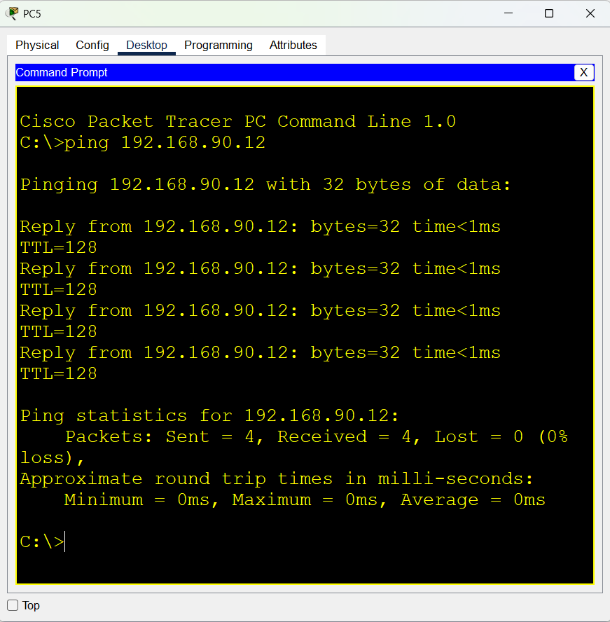

**PC04 IN SUBNET 1 TO SWITCH 3 IN SUBNET2**

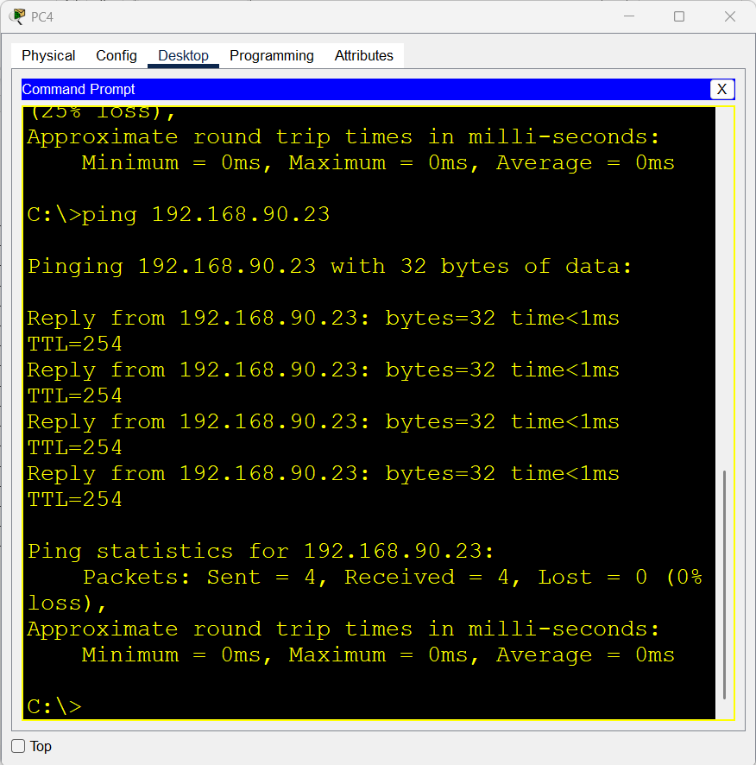

**SERVER 2 IN SUBNET 2 TO PC01 IN SUBNET 1**

**PC3 IN SUBNET 1 TO SERVER 2 IN SUBNET 2**

**SHOW RUNNING-CONFIGURATION**

**SHOW RUNNING-CONFIGURATION**

